Mesh Analysis

Qs1.. Using Mesh Analysis find Vo
Solution
Qs 2

2. Using Mesh Analysis find Io
Solution
Qs 3
Find Vo using Mesh Analysis
Solution

Qs 4
Find total power developed in the circuit using mesh analysis
Solution
Qs 5
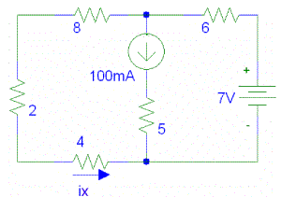
Solution
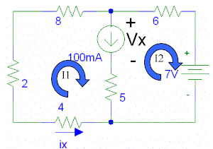
Label each mesh (window pane) with a mesh current. Then write the KVL equations for each pane. Note that we were forced to label the voltage over the current source (Vx) in order to write the voltage term there:
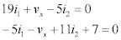
We now have an extra unknown (Vx), so we need another equation. It is found be relating the two mesh currents to the current source.
Note that i1 is positive because it is in the same direction of the source. I2 is negative because it is in the opposite direction as the source.
Now solve the three equations in three unknowns. I1 is found to be -320mA. Since ix is in the opposite direction of i1, then ix = 320mA.
Qs 6 Find Mesh Currents
Solution
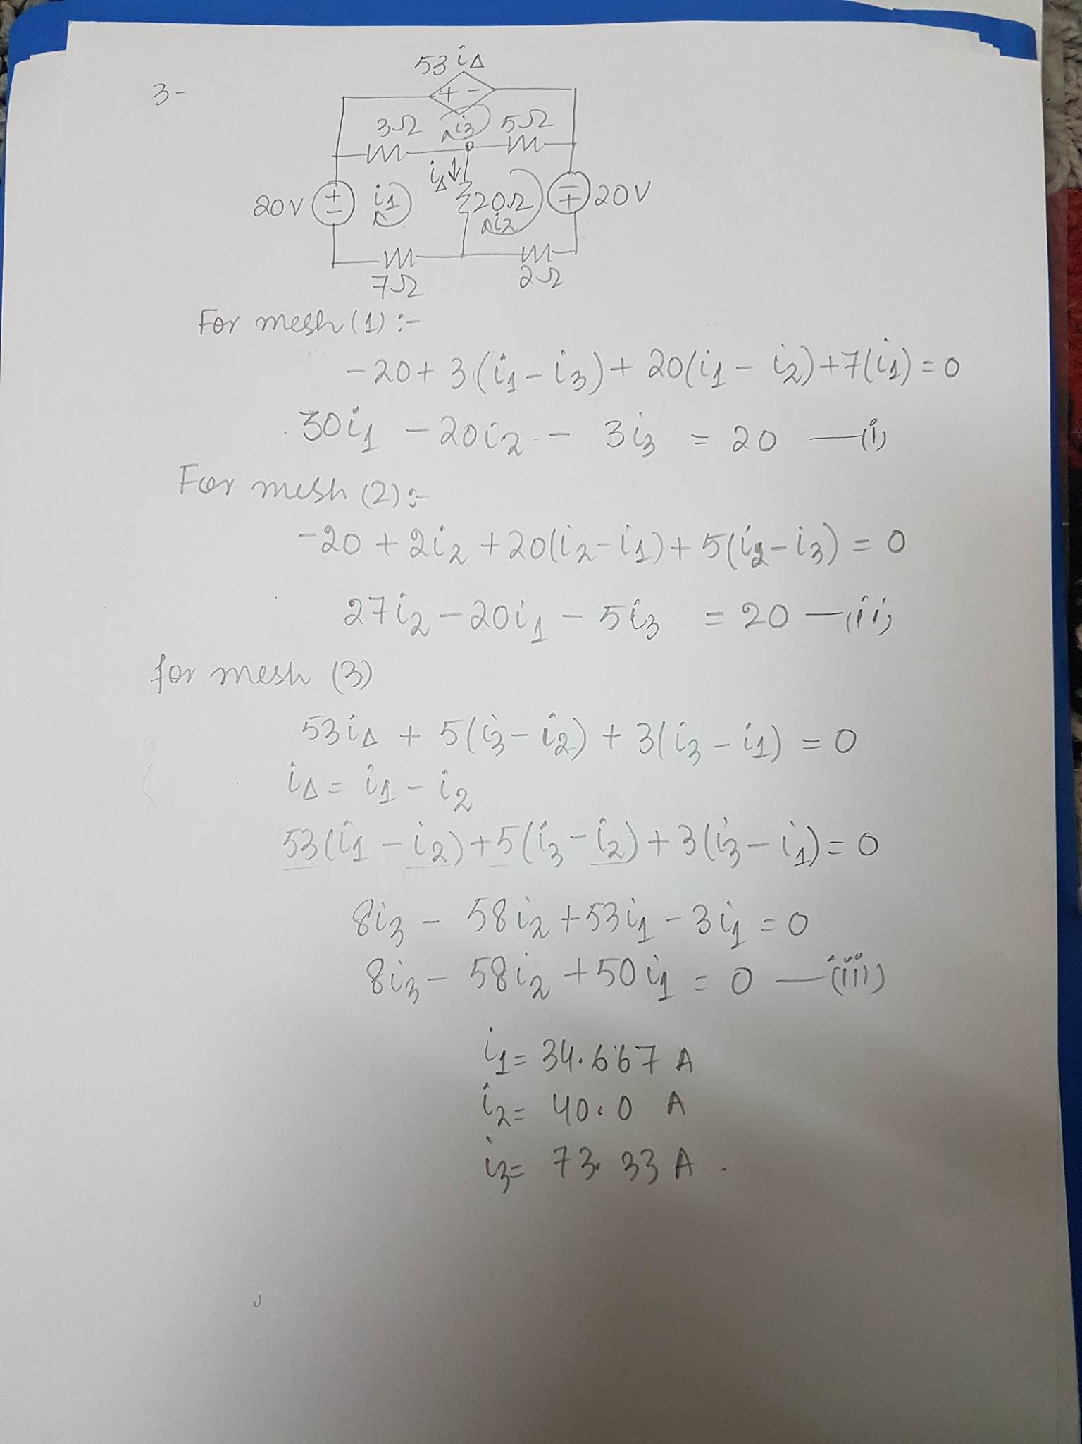
Qs 7 Find Mesh Currents
Solution
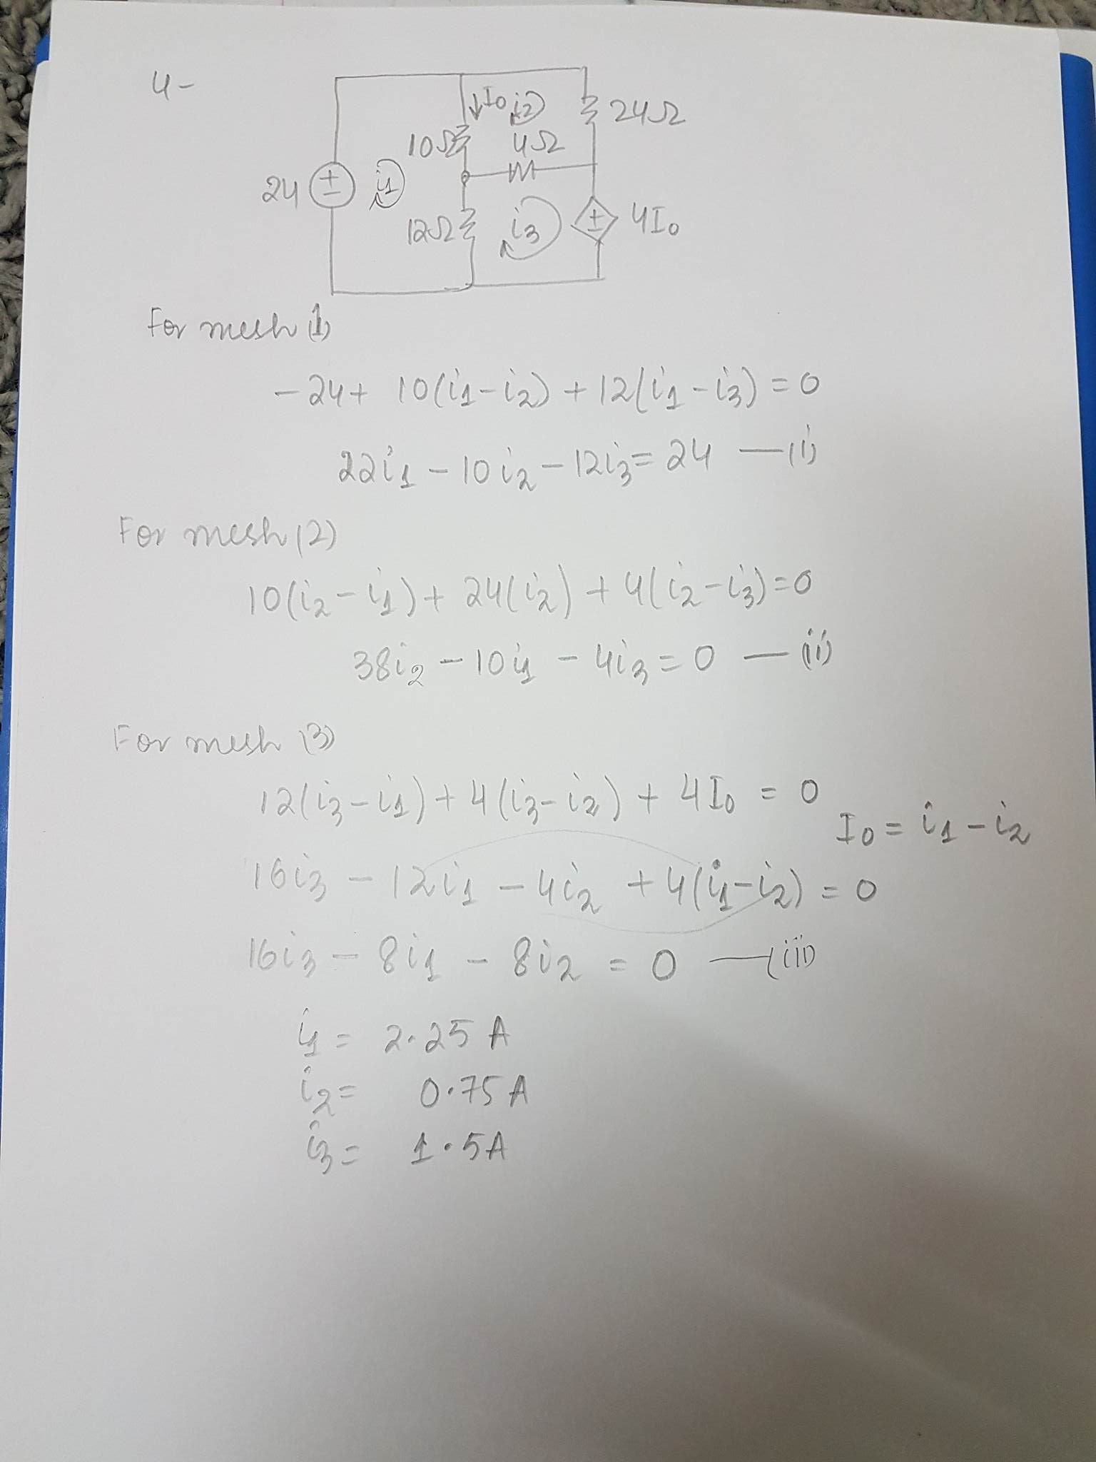

Qs 8 Find Mesh Currents
Solution
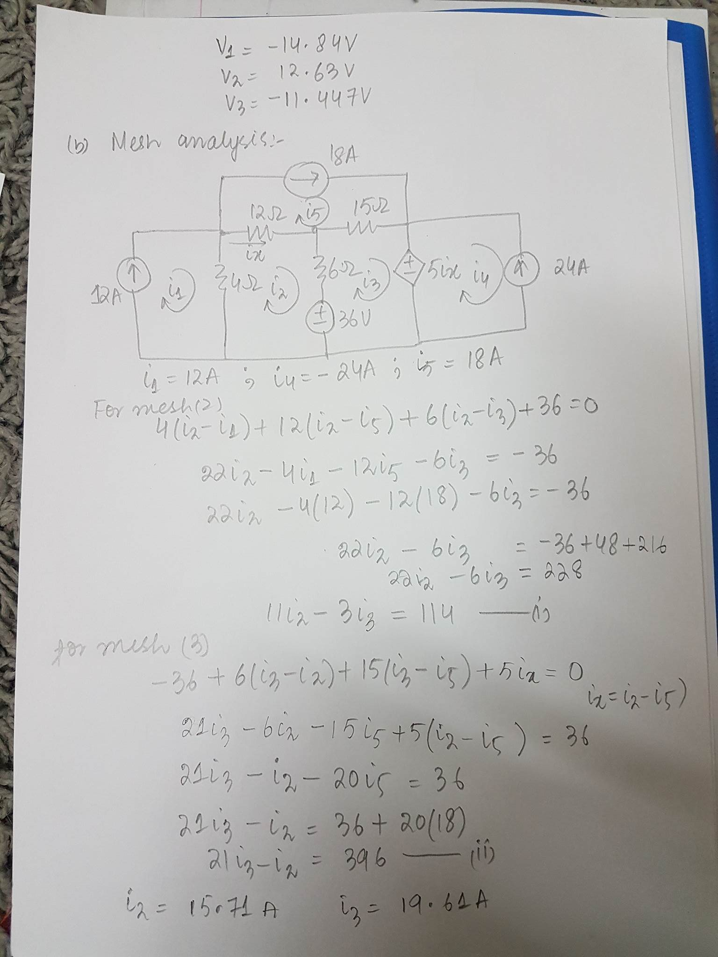
Qs 9 Find Mesh Currents
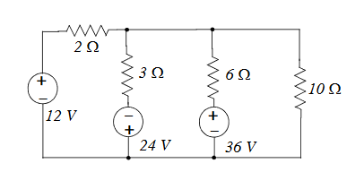
Solution
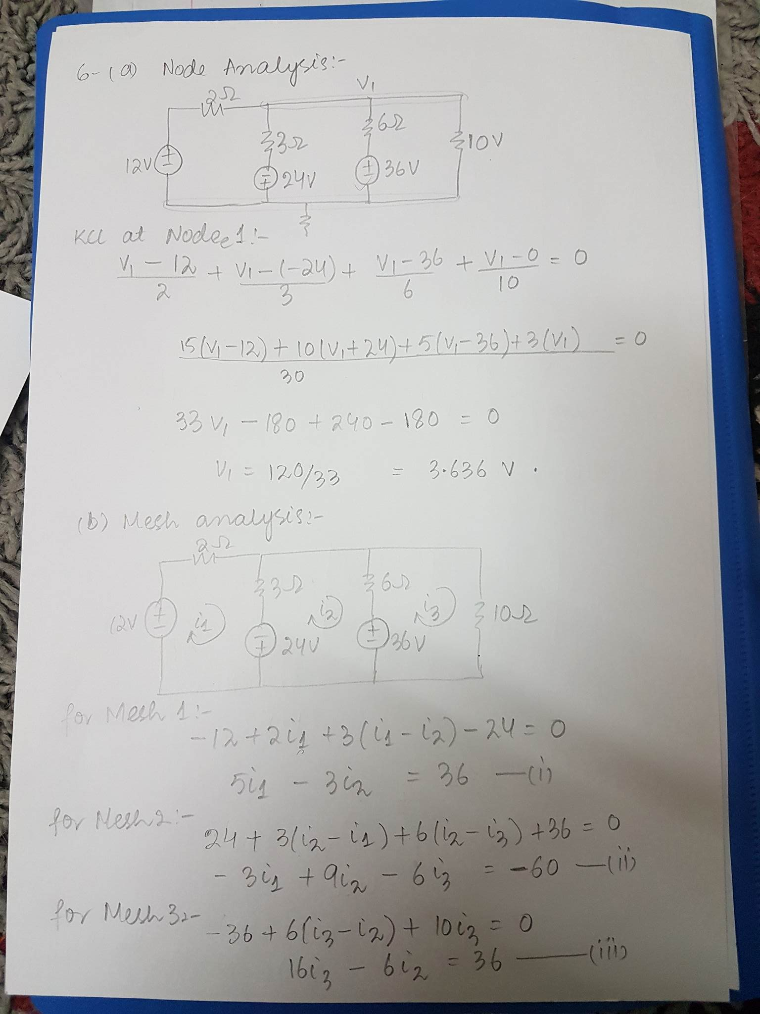
I1 = 4.182A , I2 = -5.0303A , I3 = 0.3636A
NODAL VOLTAGES

